Analysis of results.

We ran the algorithm for thirty seconds and it produced the following best solution for instance07:

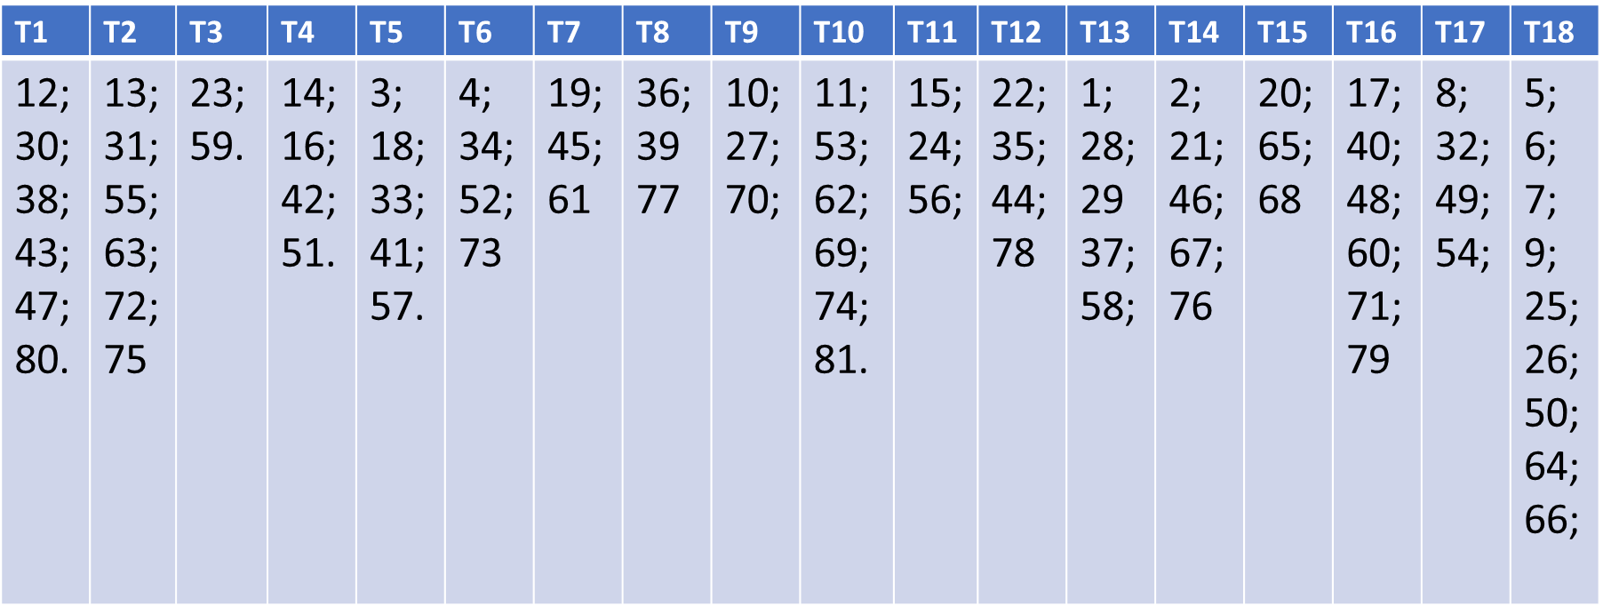

The solution is feasible and taken, for example, the exam 1 we know it is in conflict with 24 other exams, that are the following:

|  |
| --- |
| 2 3 4 5 6 7 8 9 10 11 12 13 17 18 19 20 21 23 24 26 27 46 49 |

We can check easily that there are not exams in conflict in the same timeslot of exam 1. Similar reasoning can also be done for other exams and instances.

The objective function value calculated for the instance07 is 10.585. It’s a good result because it differs from the benchmark, which is the value of object function of the best solution available in the literature, only 0.535. So we made a relative error of 5.32 %.

We obtained the best result with the instance01, in fact we make an error of 0.02%; while the worst is given by the instance06 where the error is 14.9%, maybe this is related to the fact that instance 6 has much more conflicts between exams than in the other instances. In fact for this instance the time needed to find a feasible solution is in average around 30 seconds, while other instances could find several feasible solutions in less than a second.

To sum up we made a mean error of 8.31%.